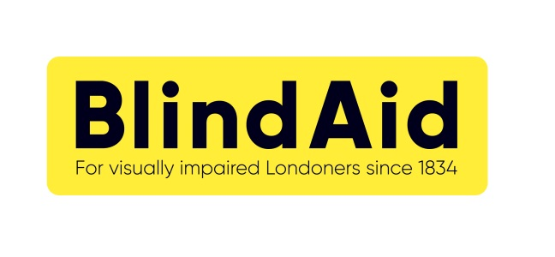**Gift Aid Declaration**

Are you a UK taxpayer?

If so, you can use Gift Aid to make your donations go further by completing this declaration. Doing so will mean that we can claim up to 25p extra for every £1 you give, at no additional cost to you! There is absolutely no obligation to make further donations but should you decide to do so we will be able to claim Gift Aid on these donations as well.



Please treat all donations I make or have made to Blind Aid for the past 4 years as Gift Aid donations until further notice.

I am a UK taxpayer and understand that if I pay less Income Tax and/or Capital Gains Tax in the current tax year (6 April to 5 April) than the amount of Gift Aid claimed on all my donations across all Charities, it is my responsibility to pay any difference.

Date of declaration:*

**Your details**

Title: First name:* Surname:*

Home address*:

Postcode:*

Email: Phone:

*\*These details are required to make a valid Gift Aid claim*

**Small but important print:**

* Gift Aid is reclaimed by the charity from the tax you pay for the current tax year (6 April to 5 April)
* You can cancel this Declaration at any time by notifying the charity
* Your home address is needed to identify you as a current UK taxpayer
* Please notify BlindAid if you:
  + want to cancel this declaration
  + change your name or home address
  + no longer pay sufficient tax on your income and/or capital gains

When completed, please return to our office on the address below.